EX NO - 1 | SETTING UP THE ENVIRONMENT AND PREPROCESSING THE DATA
23/06/2026

AIM:
To set up a fully functional machine learning development environment and to
perform data preprocessing operations like handling missing values, encoding categorical
variables, feature scaling, and splitting datasets.

ALGORITHM:
- Install Required Libraries:
  - Install numpy, pandas, matplotlib, seaborn, and scikit-learn using pip.

- Import Libraries.

- Load Dataset:
  - Load any dataset (e.g., Titanic or Iris) using pandas.

- Data Exploration:
  - Use df.info(), df.describe(), df.isnull().sum() to understand the data.

- Handle Missing Values:
  - Use .fillna() or .dropna() depending on the strategy.

- Encode Categorical Data:
  - Use pd.get_dummies() or LabelEncoder.

- Feature Scaling:
  - Normalize or standardize the numerical features using StandardScaler or

- MinMaxScaler.

- Split Dataset:
  - Use train_test_split() from sklearn to create training and testing sets.

- Display the Preprocessed Data.

CODE:
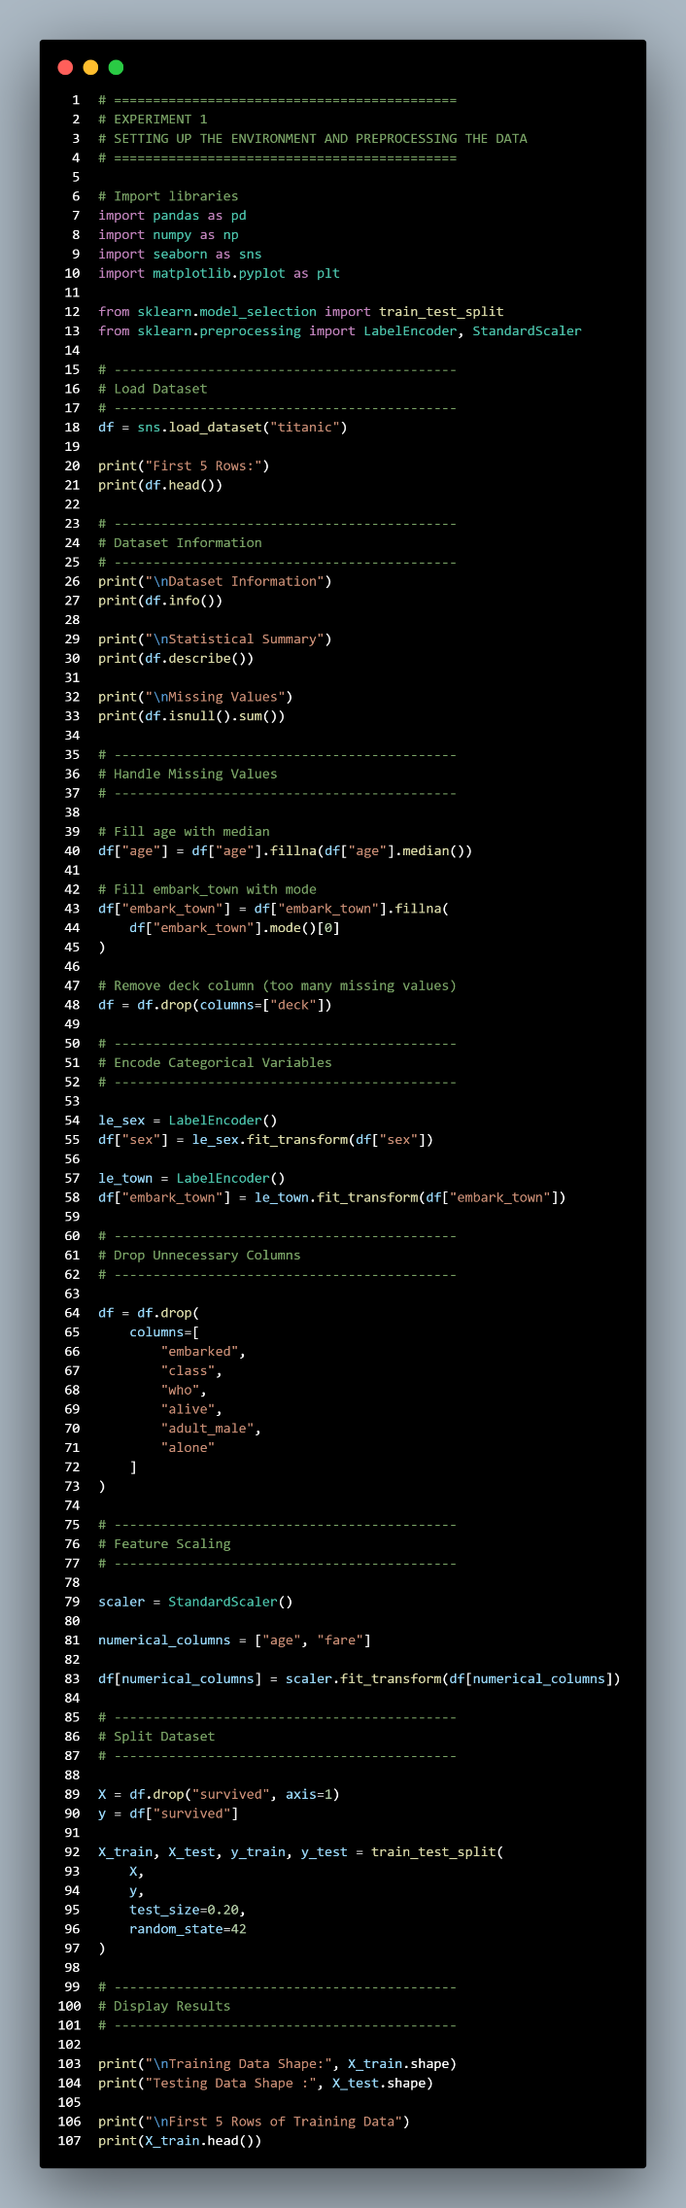

OUTPUT:
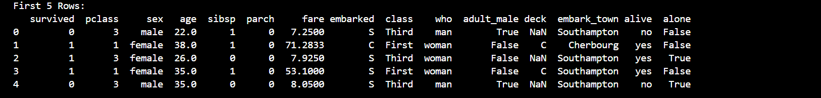
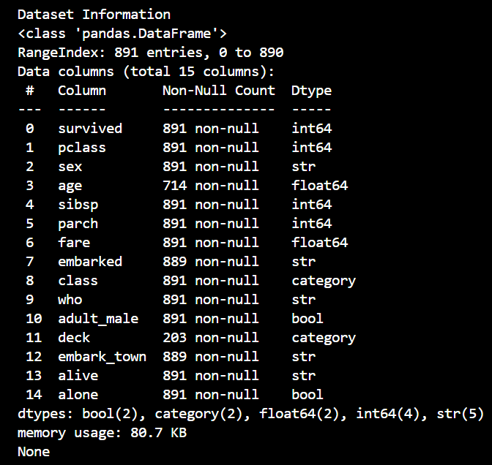
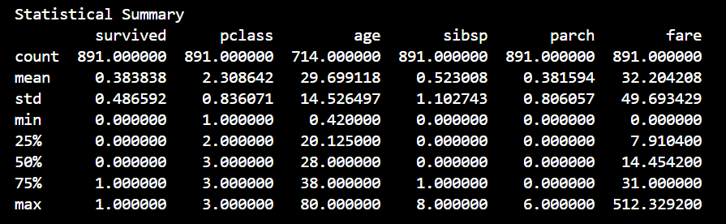
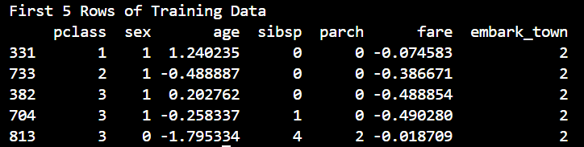
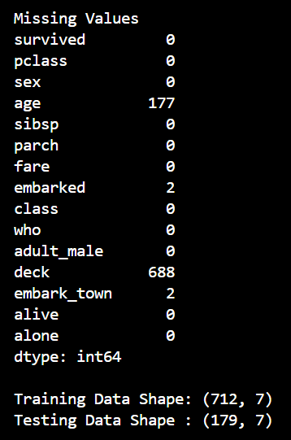

RESULT:
The Python environment was successfully set up and the dataset was pre-processed by
handling missing values, encoding categorical data, performing feature scaling, and splitting
the data into training and testing sets. The dataset is now ready for model training and
analysis.

